ATP, Photosynthesis and Cellular Respiration WebQuest Name: _____________________________________ Biology Date: ____________________ Hr: ________

Objective: In this web quest investigation, you will use the internet to research topics related to ATP, Photosynthesis, Cellular Respiration and Fermentation. Use the web links provided to answer the following questions. Happy searching!

Part I. What is ATP? http://www.biologyinmotion.com/atp/index.html

1. How does energy get converted from food molecules to muscles? ________________________________

2. According to the webpage, the analogy for ATP is that ATP works like a rechargeable ____________.

3. Click on the arrow to the next page. Pull apart the ice cream. What happens when food is broken down in the body?

4. Pull a Phosphate from the recharged ATP, what happens?

Part 11. What is Photosynthesis? http://www.biology.ualberta.ca/facilities/multimedia/uploads/alberta/Photo.html

5. Where in the plant does photosynthesis take place? ____________________________

6. The energy from the sun enters into what organelle in the plant? ___________________________

7. How does the plant get water for photosynthesis? ____________________________

8. What gas enters the plant for photosynthesis? ____________________________

9. Where does it enter the plant? ____________________________

10. What gas exits the plant during photosynthesis? ____________________________

11. Where does it exit the plant? ____________________________

12. What is the overall equation for photosynthesis? ____________________________

http://www.webexhibits.org/causesofcolor/7A.html

13. Plants contain what two forms of Chlorophyll?

14. What color of light is absorbed best by plants? 2nd best? Reflected?

15. What metal ion is found at the center of the Chlorophyll molecule?

16. During photosynthesis what happens to the electrons?
Overview of Photosynthesis Labeling. Label the following picture below. http://www.phschool.com/science/biology_place/biocoach/photosynth/overview.html

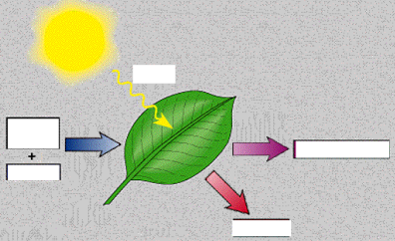

Part III: “Autumn Leaves – Why do leaves change color in the Fall?”
http://www.sciencemadesimple.com/leaves.html

1 What do plants do during the winter? Why must they do this?

2 During the winter, what happens to the chlorophyll in the leaves?

3 Why can’t we see the yellows and oranges in the summer?

4 What causes maple leaves to appear red?

5 What causes oak leaves to appear brown?

Part IV: What is Cellular Respiration? http://www.qcc.cuny.edu/BiologicalSciences/Faculty/DMeyer/respiration.html

13. What molecule enters Glycolysis?

14. What gas (in white) is released during the Krebs cycle?

15. What molecule (in purple) is released from the Krebs cycle and enters the Electron transport chain?

16. What molecule (in dark blue) is released as a product from the Electron transport chain?

17. What energy molecule in Teal is restored as a product of cellular respiration? What is Glycolysis? http://highered.mcgrawhill.com/sites/0072507470/student_view0/chapter25/animation__how_glycolysis_works.html

18. What is the main reactant for glycolysis? ___________________________________________

19. What is the product of glycolysis? __________________________

20. How many ATP molecules of ATP are used to start glycolysis? ___________

21. What are the 3 carbon molecules called? ____________________________________________

22. What molecule is required for aerobic conditions? (think!) ______________________________

23. What happens if there are anaerobic conditions, what is pyruvate converted into by animals and by yeasts?

_______________________ (Aka the source of sore muscles!) & ___________________________

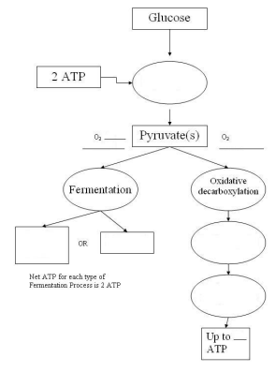

Overview of Cellular Respiration Labeling. Label the following picture to the left. https://simple.wikipedia.org/wiki/Cellular_respiration

OR

http://www.tutorvista.com/biology/the-cellular-respiration-process

Part V: Anaerobic vs Aerobic Respiration
http://www.tutorvista.com/content/biology/biology-ii/respiration/aerobic-and-anaerobic.php#

Scroll down to Anaerobic Respiration

24. What is the difference between aerobic and anaerobic cellular respiration?

25. What is lactic acid fermentation? Where does it occur?

26. What does a build up of lactic acid cause?

27. What is alcoholic fermentation?

28. In what industry is alcoholic fermentation important? [List several and use]

29. Which produces the larger amount of energy – aerobic or anaerobic respiration?
Support your answer with information from the reading.

30. Write a summary of cellular respiration. In your response:
• State the function of cellular respiration
• Identify the site of cellular respiration
• Compare aerobic and anaerobic forms of cellular respiration

Upon Completion of the WebQuest you may play the following game or do the interactive: http://www.biomanbio.com/GamesandLabs/PhotoRespgames/phorespgame.html
OR http://www.pbs.org/wgbh/nova/nature/photosynthesis.html

