Name: ________________ Date: _________

The Human Heart

Instructions: Use the diagram of the human heart to answer the questions.
1. | 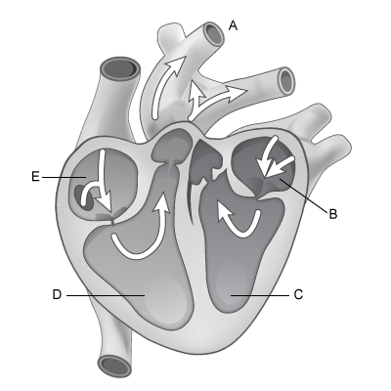  Which letter represents the right ventricle?  - A  - B  C  D  - E
2. | Which letter represents the left ventricle?  - A  - B  - C  - D  - E
3. | Which letter represents the right atrium?  - A  - B  - C  - D  - E
4. | Which letter represents the left atrium?  - A  - B  - C  - D  - E
5. | Which letter represents the aorta?  - A  B  - C  D  - E
6. | Which letters represent the parts of the heart that pump blood to the body?  - B and C  - C and D  - D and E  - E and B
7. | Which letters represent the parts of the heart that receive blood from the body?  - B and C  - C and D  - D and E  - E and B
8. | In the human heart, blood from the lungs enters the heart through the left atrium, pumps into the left ventricle, out the aorta and through the body, then returns into the right atrium, pumps into the right ventricle and exits to the lungs. Using the above diagram, which set of letters correctly represents this process?  - E, D, A, B, C  - B, C, A, E, D  - C, D, A, B, E  - D, C, A, E, B
9. | Feature "A" on the diagram above represents the largest vein in the human body.  - True  - False
10. | The myocardium, or muscle, around parts C and D of the heart is thicker than the myocardium around parts B and E of the heart.  - True  - False

