Biology Genetics Set #1 Name: _______________
- Hitchhiker’s Thumb (H) is dominant to no hitchhiker’s thumb(h). A woman who does not have hitchhiker’s thumb is married to a man who is heterozygous for hitchhiker’s thumb. What is the probably genotypic ratio of their children?
H H
H HH HH
h Hh Hh

- Can the following set of parents have a child with Type O blood? Show your cross to support your answer.
  - Type AB x Type B No
  - Type AB x Type O No
  - Heterozygous Type A x Type O Yes
  - Homozygous Type A x Type O No

- The chart shows several crosses with white-feathered chickens and dark-feathered chickens.
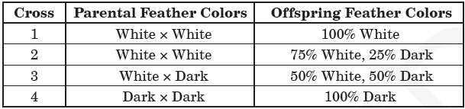

Which cross would represent the cross Aa x aa, where (A) is the dominant and (a) is the recessive allele? SHOW YOUR CROSS TO SUPPORT YOUR ANSWER. #3
A a
A AA Aa
A AA Aa

Incomplete Dominance vs. Codominance
4. A mating between a black goose and a white goose produces blue-gray offspring. (Blue-gray is an intermediate color between black and white.) Is this an example of incomplete dominance or codominance?___________Incomplete produces a new color______________
Fill in the phenotypes below for the geese in problem 4.
B B = black
BB’=___blue-gray_________
B'B'=__white___

5. Make a Punnett square showing a cross between a black goose and a blue-gray goose. What percentage of offspring would be black?
BB | BB
BB’ | BB’
B B
Answer:___50%_______% Bbbb
B
B’
B
6. A reddish/brown-haired cow when crossed with a white-haired cow produces offspring that have reddish/brown hairs AND white hairs (This color is called roan). Is this an example of incomplete dominance or codominance? _________________________________________
Fill in the missing genotype and phenotype below for problem 6.
RR = Reddish/Brown
___=Roan
WW = ____________________

7. Make a Punnett square that shows the cross described in #6. What percentage of the offspring will be heterozygous?

Answer: __________%
Karyotypes
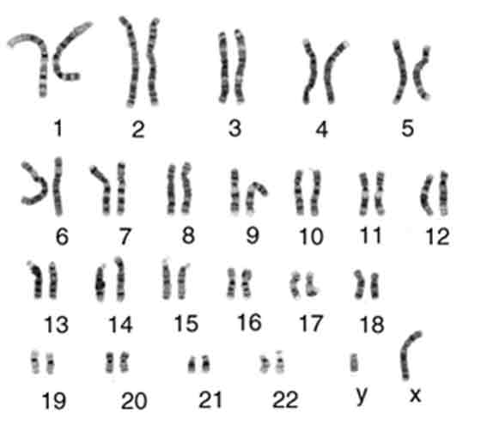
8. There are _________ chromosomes in a human somatic cell.

9. A male has _________ chromosomes for the 23rd pair and a female has _________ chromosomes for the 23rd pair.

10. A person with down syndrome has an extra chromosome in the ___________ chromosome pair.

11. A person with Klinefelter’s syndrome can be recognized by an _________.
12. Both down syndrome and Klinefelter’s syndrome are a form of ______________because they have an abnormal number of chromosomes.

13. A person with Turner’s Syndrome can be recognized as missing which chromosome? __________ They are considered a _____________ because they only have one chromosome 23.

Review of Mitosis and Meiosis
Which diagram is which? Fill in the FINAL chromosome #’s.

Meiosis, Haploid, 15 chromosomes
30
30

Mitosis, Diploid, 30 chromosomes
Complete the following chart comparing mitosis and meiosis
Characteristic | MITOSIS | MEIOSIS
Location(s) where process occurs | All cells except sex cells | Ovaries/Testicals
number of cells produced | 2 | 4
chromosome number of parent nucleus (haploid/diploid) | Diploid 2n | Diploid n
chromosome number of new nucleus | Diploid 2n | Haploid n
type of cell produced  (body cell/gamete) | Body cells (somatic cells) | gametes
function in the organism | Growth & repair | Formation of gametes

1. If a Cow sperm cell contains 30 chromosomes, how many chromosomes are in a cow heart cell?
  - 30 b. 60 c. 90 d. 120

2. If you fall and scraped your knee while walking to the bus stop, what process will repair your wound?
a. Osmosis b. Mitosis c. respiration d. Meiosis

3. Which of the following represents the predicted product of Meiosis in a human cell?
a. Two cells with 46 chromosomes
  - Eight cells with 23 pairs of chromosomes
  - Four cells with 23 chromosomes
d. Three cells with 23 chromosomes

4. Which division produces haploid cells that are genetically recombinant due to crossing over and independent assortment? Circle: Mitosis or Meiosis

