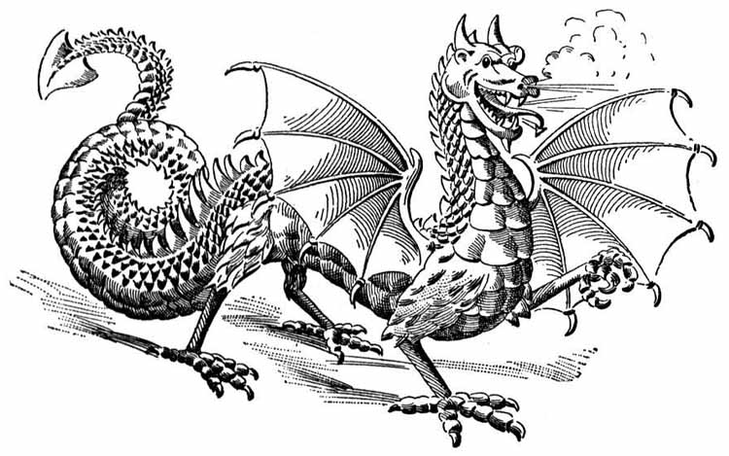
Dragon Genetics: Mixed Review Name/Date: __________________________________

1. Which represents the genotype of a homozygous recessive trait?
A BC C bb
B bc D Bb

2. Which statement describes how two dragons may show the same phenotypic trait, yet have different genotypes for that phenotype?
A One is homozygous dominant and the other heterozygous.
B Both are heterozygous for the dominant trait.
C One is homozygous dominant and the other homozygous recessive.
D Both are homozygous for the dominant trait.

3. In dragons, Fire Breathing (F) is dominant over Non-Fire Breathing (f). If some of the offspring of a cross between a Fire Breathing dragon and a Non-Fire Breathing dragon are Non-Fire Breathing dragons, the Fire Breathing Dragon parent must have been
A a mutation C homozygous
B heterozygous D a polyploid

4. If the female dragon’s genotype is represented by ff and the male dragon’s genotype is Ff, what percentage of their offspring would be expected to be fire breathers? [Draw punnett sq!]
A 75% C 50%
B 100% D 0% f f
F Ff Ff
f ff ff

5. The appearance of a recessive trait in the offspring of animals most probably indicates that
A both parents carried at least one recessive gene for the trait.
B one parent was homozygous dominant and the other parent was hybrid (heterozygous) for that trait
C one parent was homozygous dominant and the other parent was homozygous recessive for that trait
D neither parent carried a recessive gene for that trait

6. In dragons, dull scales are dominant over shiny scales. If two dragons, both heterozygous for scale luster are mated, their offspring would be expected to have
A 75 % dull scales, 25 % shiny scales
B 75 % shiny scales, 25 % dull scales
C 50 % shiny scales, 50% dull scales
D 100% dull scales

7. The best way to determine if a dragon has the phenotype of shiny scales is to simply
A prepare a Karyotype
B analyze a blood sample
C x-ray the animal
D observe the organism on a sunny day

8. Three dragon brothers have blood types A, B, and O. [Can you believe that dragons have the same blood types as humans?] What are the chances that their parents will produce a fourth dragon whose blood type is AB? [Remember to work punnett sq backwards!]
A 50% C 25%
B 0% D 100%

9. A dragon heterozygous for blood type A is mated to a female dragon with blood type AB. The blood type of their offspring could not be [use punnett sq!]
A A C AB
B O D B

10. Crosses between golden-eyed dragons (R’R’) and red-eyed dragons (RR) produce variegated color patterns of both gold and red within the iris ( the colored part of the eye). This combination of golden and red eye color is known as mystic eye (R’R). This type of inheritance pattern is known as
A incomplete dominance
B crossing-over
C multiple allele inheritance
D codominance

11. Crosses between a blue hide dragon (BB) and a yellow hide dragon (YY) produce green hide dragon offspring (BY). This type of inheritance pattern is known as
A incomplete dominance
B crossing-over
C multiple allele inheritance
D codominance

Night vision in dragons is a sex-linked recessive disorder. Although night vision seems to be an excellent characteristic, night vision dragons develop cataracts early in life which is detrimental to wild dragons.

12. A male dragon that has normal vision [does not have night vision] is crossed with a female dragon with night vision. What percent of the male dragon offspring produced are expected to have night vision?
A 0% C 33%
B 75% D 100%

13. A male dragon that has normal vision is mated with a female dragon that also has normal vision but whose father had night vision.

The chances of having a female offspring with night vision is
A 0% C 100%
B 75% D 25%

The chances of having a male offspring with night vision is
A 0% C 100%
B 50% D 25%

