Biology Genetics Set #2
Disorder | Recessive or Dominant? | Autosomal or Sex-linked?
Huntington's Disease | - Dominant | - Autosomal
Muscular Dystrophy | - recessive | - Autosomal
PKU | - recessive | - Autosomal
Hemophilia | - recessive | - Sex-linked
Sickle Cell Anemia | - recessive | - Autosomal
Cystic Fibrosis | - recessive | - Autosomal
Tay Sachs | - recessive | - Autosomal
Colorblindness | - recessive | - Sex-linked
- Which disorder affects a membrane protein causing the individual to produce excess mucus in the lungs? Cystic Fibrosis
- Which disorder affects hemoglobin resulting in misshapen red blood cells? Sickle Cell
- Which disorder affects an enzyme that breaks down an amino acid but can be controlled by diet? PKU
- Which disorder doesn't present symptoms until age 40? Huntington’s

- One of the parents of a child has PKU, which is caused by recessive alleles. The other parent does not have any PKU alleles.
  - What is the genotype of the parent with PKU? ____________________ rr
  - What is the genotype of the parent without PKU? __________________ RR
  - What are the chances that they will have a child with PKU? ___________ 0%

- A normal woman whose father was a hemophiliac marries a normal man.
  - What percent of male and female children would be hemophiliacs? 25%
  - What percent normal children? 75%
  - Would any be carriers? What %? 25%

X^{H} X^{h}
X^{H} X^{H} X^{H} X^{H} X^{h}
Y X^{H} Y X^{h} Y

- Can a color blind female have a son that has normal vision? Show the cross to indicate whether or not she can. NO
X^{r} X^{r}
X^{R}
Y X^{r} Y X^{r} Y
- Below is a Pedigree, showing a sex-linked recessive disorder.
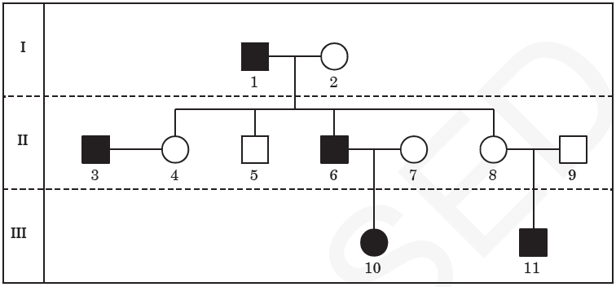
- What is the genotype of individual #6? X^{r} Y

- What is the genotype of individual #2 X^{R} X^{r}

- What are the two sex-linked recessive traits you need to know?
Fathers pass trait to daughters that are carriers. Mothers pass to sons.

The pedigree shows the inheritance pattern of cystic fibrosis.
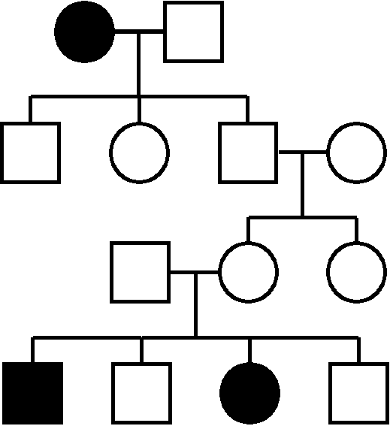
- Is this disorder recessive or dominant?
1.
2.
I.
Recessive
- Is this disorder sex-linked or autosomal? How can you tell?
II.
1.
Autosomal
1.
- What is the genotype of individual II-1?
III.
Rr
1.
- What is the genotype of individual IV-1?
IV.
rr

