Biology
Pedigree #1 Name: _____________________________ Date: _____________

Background

A pedigree is a chart that shows the inheritance of a trait in a family. It usually tracks a particular trait or disease through several generations.
A square represents a male individual. A circle represents a female.
A shape that is filled in means that individual has the trait. An empty shape means he/she does not show the trait.
A straight horizontal line between a male and female represents a "marriage" or mating line. A vertical line descending from a marriage line represents the offspring of the parents.
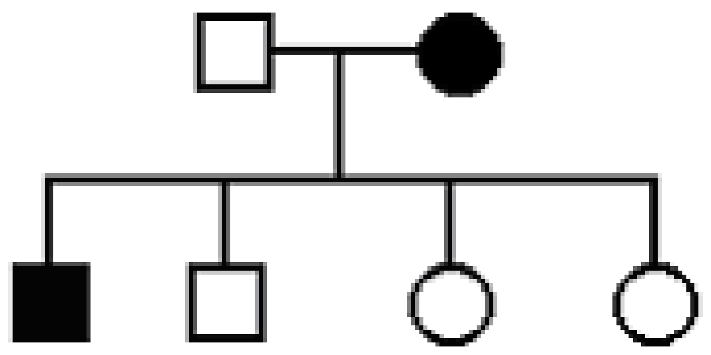
Here’s an example:
In this pedigree the parents had four offspring; two male and two female. The mother and one of the sons show the trait, but no one else does.
The pedigree only shows the phenotype, not the genotype and not whether a trait is dominant or recessive.

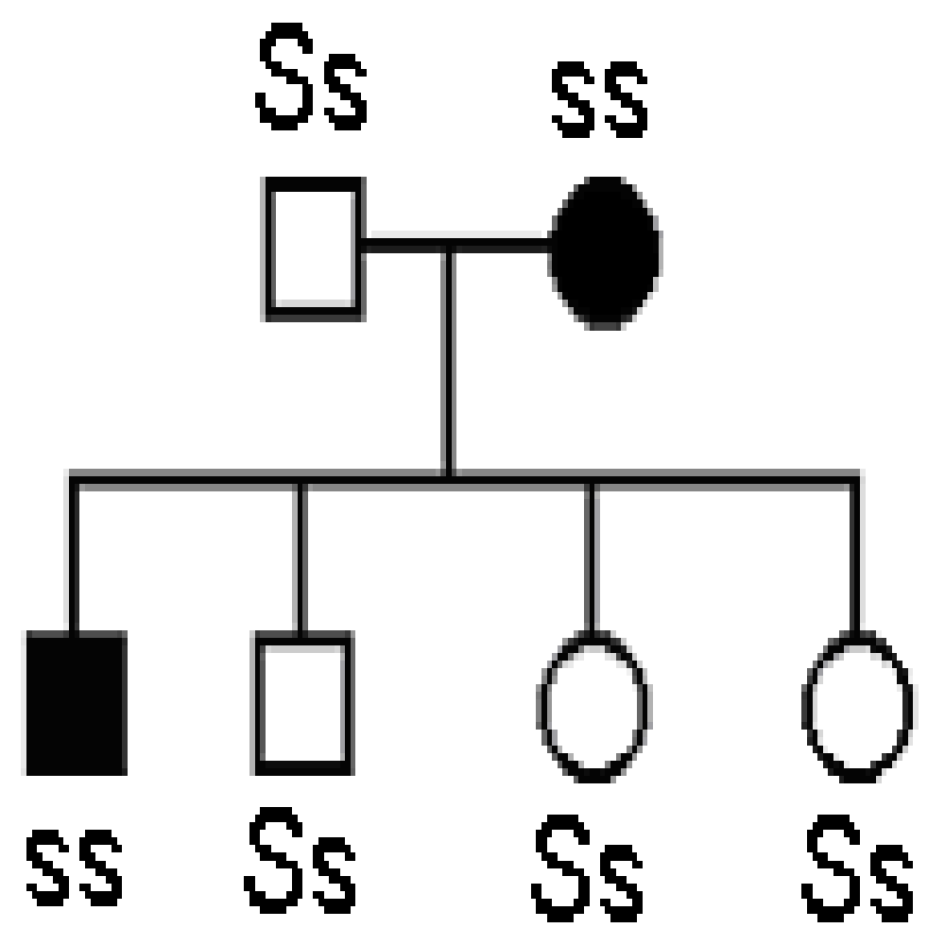
For example, some members of this family are allergic to strawberries (s) and some are not (S). Here is the same pedigree with the genotypes. See if it you can see why some individuals show the trait and some do not.

Here are a few rules of logic to help you understand the genetics behind the pedigree:

1. If neither parent show the trait:
a. the trait cannot be dominant.
b. the trait could be recessive and either parent or both could be heterozygous carriers.

2. If one parent shows the trait:
a. the trait could be dominant and the affected parent could be heterozygous while the unaffected parent is not a carrier
b. the trait could be recessive and the affected parent is homozygous while the unaffected parent could be a heterozygous carrier

3. If both parents show the trait:
a. the trait could be dominant and both parents could be heterozygous carriers which means that some of the children could be unaffected
b. the trait could be recessive meaning that both parents would have to be homozygous and all the children would have to be affected

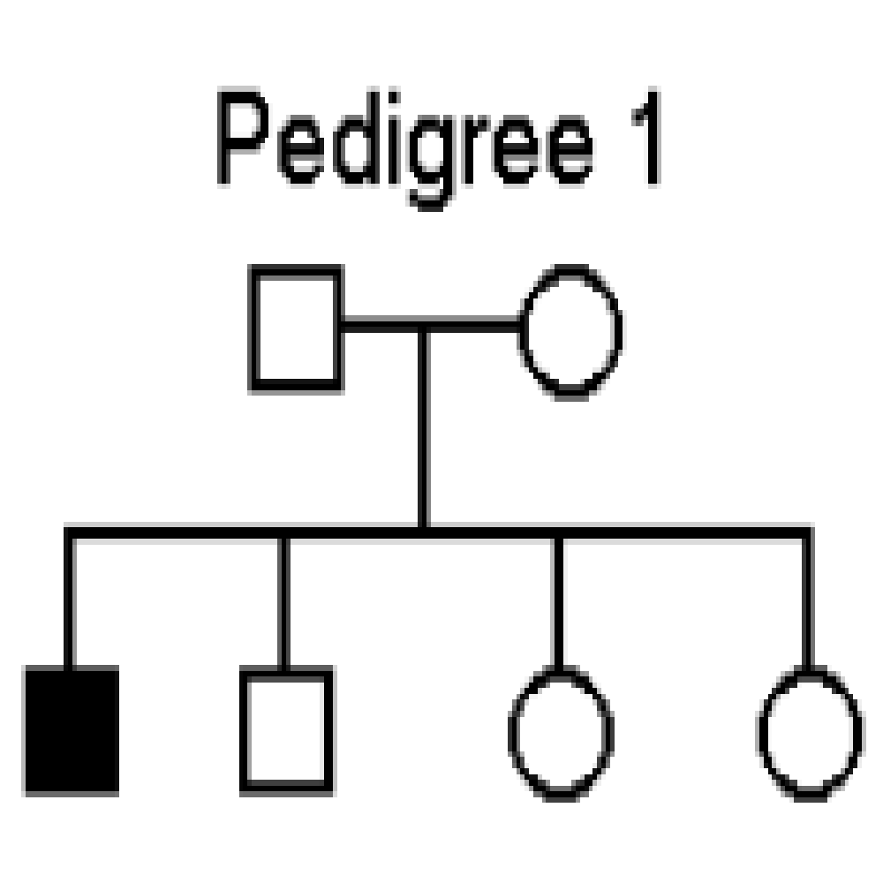
Problems:
- Pedigree 1 shows a family of parrots. One of the offspring shows the trait for
blue feathers. (R = red feathers, r = blue feathers)
1. Do you think blue feathers are dominant or recessive? ______________
2. What must the genotypes of the parents be? _______________
3. What two genotypes could the other offspring have? _______________

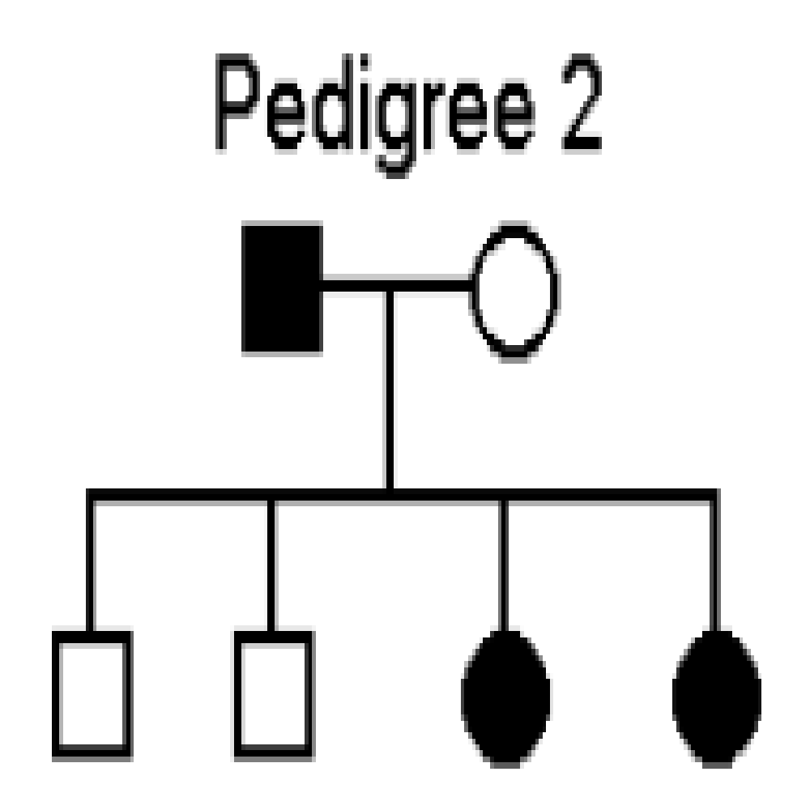
- Pedigree 2 shows two banana trees that were crossed to produce four F1 plants.
Shaded individuals have green leaves. Some of the plants have green
leaves and some have yellow leaves.
1. If green leaves are dominant, which parent has green leaves and which
has yellow leaves? _________________________________________
2. If yellow leaves are dominant what is the genotypes of the offspring? _______________________

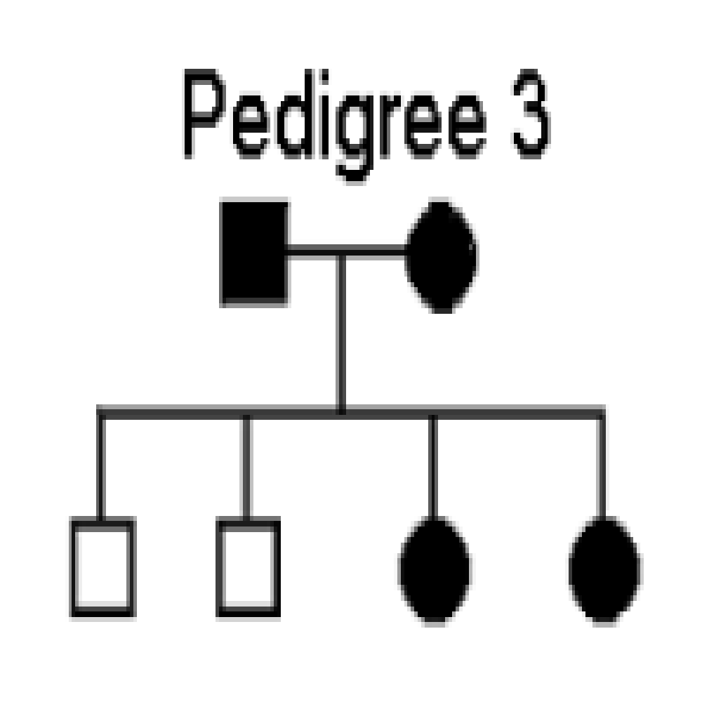
- Pedigree 3 is studying hair color in a family. In humans, dark hair (B) is dominant to blonde hair (b). In this case, individuals who are shaded are dark-haired. Individuals who have clear circles are blonde.
1. What are the genotypes of the parents? _____________________
2. What is the genotype of the sons? _______________________
3. What are the two possible genotypes of the daughters? ________________________

- Pedigree 4 shows a family that has carried the gene for albinism, a recessive gene. A carrier has the gene, but doesn’t show the trait (i.e. heterozygous for albinism, Aa). In the pedigree, mark all family members that you think are carriers for albinism like this: Assume that spouses from outside the family are not carriers.

